

Medical Diagnosis Center
BY-- V.LAHARI
Phase 1
Description
The Medical Diagnosis Center by Service Portal (ServiceNow) project focuses on developing a digital healthcare service portal to manage patient services, appointments, diagnostic requests, and medical records efficiently. The solution enables patients to submit service requests, track appointment status, access diagnostic information, and communicate with healthcare teams through a user-friendly ServiceNow Service Portal interface. It improves healthcare service delivery by automating workflows, managing requests, and providing better coordination between patients, doctors, and support staff.
Requirements for Medical Diagnosis Center Application
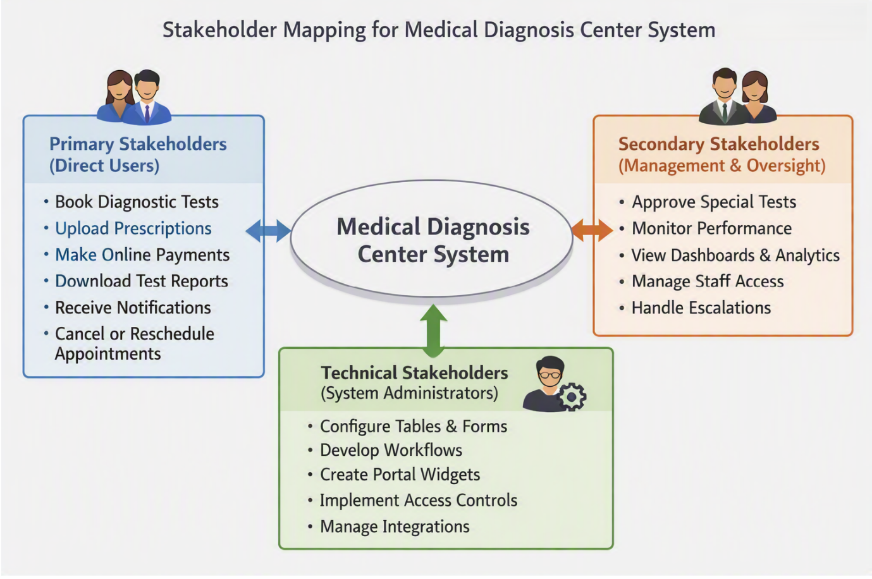
1. User & Role Management
- Support distinct roles and access permissions for Patients, Lab Staff, and Administrators.
2. Test Booking & Appointment Management
- Provide a user-friendly interface to browse available medical tests and book appointments.
- Implement real-time slot validation to limit bookings per slot and prevent overlapping appointments.
- Enforce rules for advance booking limits and cancellation/refund policies.
3. Workflow & Approval Process
- Automate state transitions: Requested → Pending Approval → Confirmed → Sample Collected → Processing → Completed → Report Available.
- Support optional manager approvals for specialized tests and escalation triggers for delayed reports.
4. Medical Reports & Payments
- Allow patients to view and download completed diagnostic reports securely.
- Integrate payment processing and generate payment confirmations.
5. Notifications & Alerts
- Trigger automated notifications (email/system) for booking confirmations, approval statuses, payment receipts, and report availability.

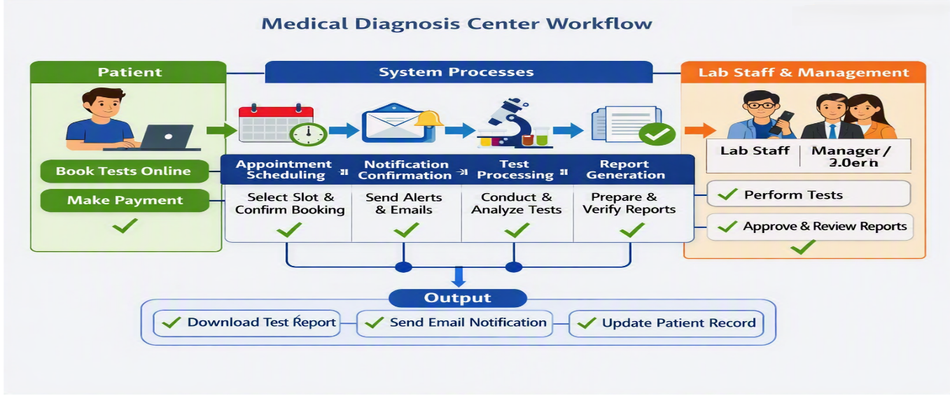
Phase -2
Creating the Medical Diagnosis Center Application
The first step of the project is to create a new application in the ServiceNow Developer Instance. This application is used to manage all the features of the Medical Diagnosis Center.
Steps to Create the Application
Step 1: Login
Log in to the ServiceNow Developer Instance.
Step 2: Open Studio
Go to:
All → System Applications → Studio
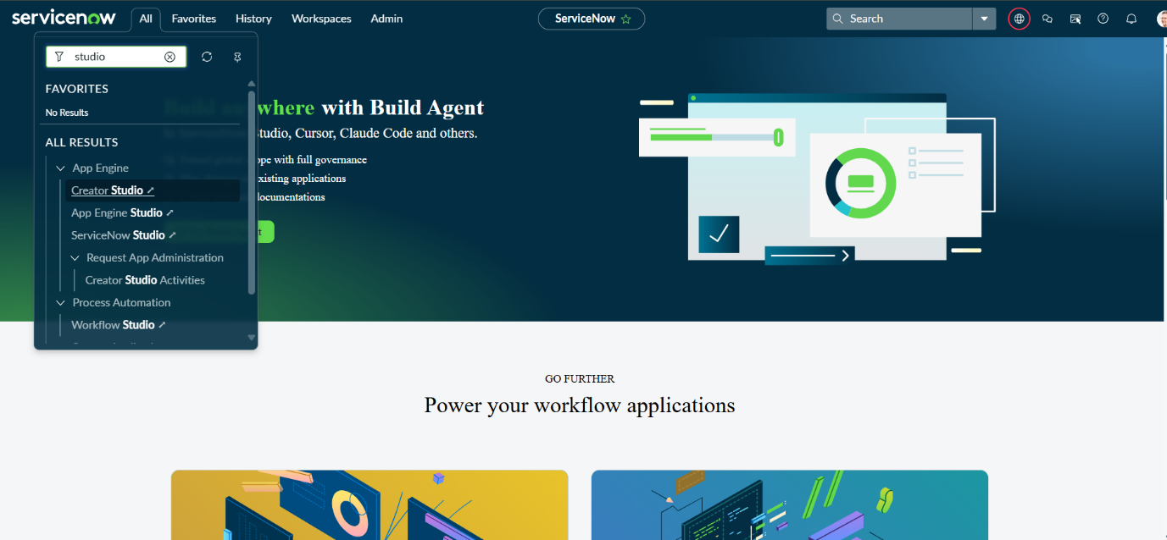
Studio is used to create and manage ServiceNow applications.
Step 3: Create Application
Click Create Application and enter the following details:
- Application Name: Medical Diagnosis Center
- Scope Name: x_1955296_medica_0 (automatically generated)
- Description: Application to manage diagnostic test booking, reports, payments, and workflow automation.
Click Create.
Step 4: Application Created
After clicking Create, ServiceNow creates the application and opens it in Studio.
The application will be used to create different parts of the project, such as:
- Patient Registration
- Test Booking
- Appointment Management
- Report Management
- Payment
- Notifications
- Workflows
- Reports and Dashboards
Step 5: Default Roles
ServiceNow automatically creates the default application roles.
These roles help control which users can access the application.
Additional roles can be created later for:
- Patient
- Receptionist
- Lab Technician
- Lab Manager
- Administrator
Updating the Application
After creating the application, it can be updated whenever new features are added or existing features need to be changed.
For example, tables, workflows, business rules, Service Portal pages, notifications, and reports can be added to the application.
Purpose
Updating the application helps to:
- Add new features.
- Modify existing features.
- Manage application components.
- Control user access.
- Keep the project organized.
Result
The Medical Diagnosis Center application is successfully created in ServiceNow. It provides a central place to develop and manage all the components required for the project.
Application Name: Medical Diagnosis Center
Scope Name: x_1955296_medica_0
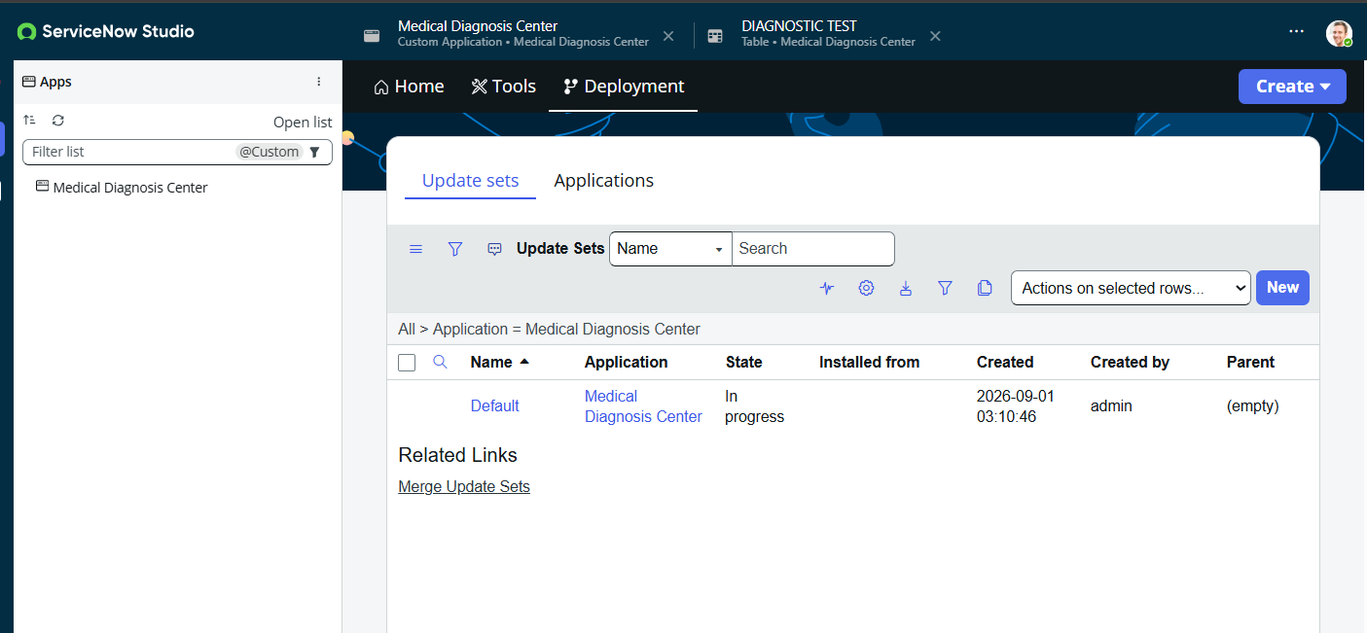

Table Creation and Field Configuration
Tables are used in ServiceNow to store and manage application data. For the Medical Diagnosis Center application, two important tables are created:
- Appointment Table
- Diagnostic Test Table
These tables help the system manage patient appointments and diagnostic test information.

Activity 1: Appointment Table Creation
The Appointment Table stores information about patient appointments, test bookings, approval details, payment status, and appointment status.
Steps to Create the Table
- Open the ServiceNow Developer Instance.
- Go to System Definition → Tables.
- Click New.
- Enter the following details:
Field | Value
Label | Appointment Table
Name | x_1955296_medica_0_appointment_table
Application | Medical Diagnosis Center
- Check that the correct application is selected.
- Click Submit.
The Appointment Table is now created.
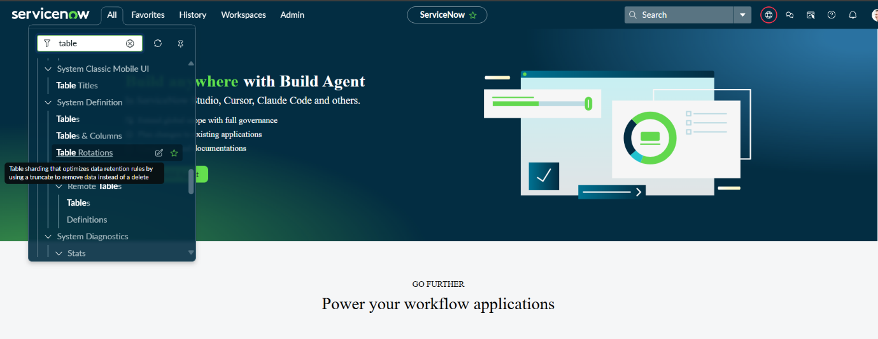

Activity 2: Creating Fields in Appointment Table
Fields are used to store different types of information in a table.
Fields can be added using:
- Form Builder
- Form Design
- Form Layout
For this project, the following fields are created in the Appointment Table.
Appointment Table Fields
Field Label | Field Name | Field Type | Reference / Choices
Appointment Number | appointment_number | String | —
Patient | patient | Reference | Patient Table
Status | status | Choice | Scheduled, Confirmed, Completed, In Progress, Cancelled
Approval Status | approval_status | Choice | Pending, Approved, Completed, Cancelled, Rejected
Email | email | Email | —
Approval Date | approval_date | Date/Time | —
Test | test | Reference | Diagnostic Test Table
Slot Time | slot_time | String | Configurable Time Slots
Total Amount | total_amount | Currency | —
Rejection Reason | rejection_reason | String (Multi-line Text) | —
Confirmation Sent | confirmation_sent | Boolean | True / False
Created By | created_by | Reference | sys_user
Approved By | approved_by | Reference | sys_user
Notes | notes | String (Multi-line Text) | —
Payment Status | payment_status | Choice | Pending, Paid, Failed, Refunded
Scheduled Date | scheduled_date | Date/Time | —
Refund Amount | refund_amount | Currency | —

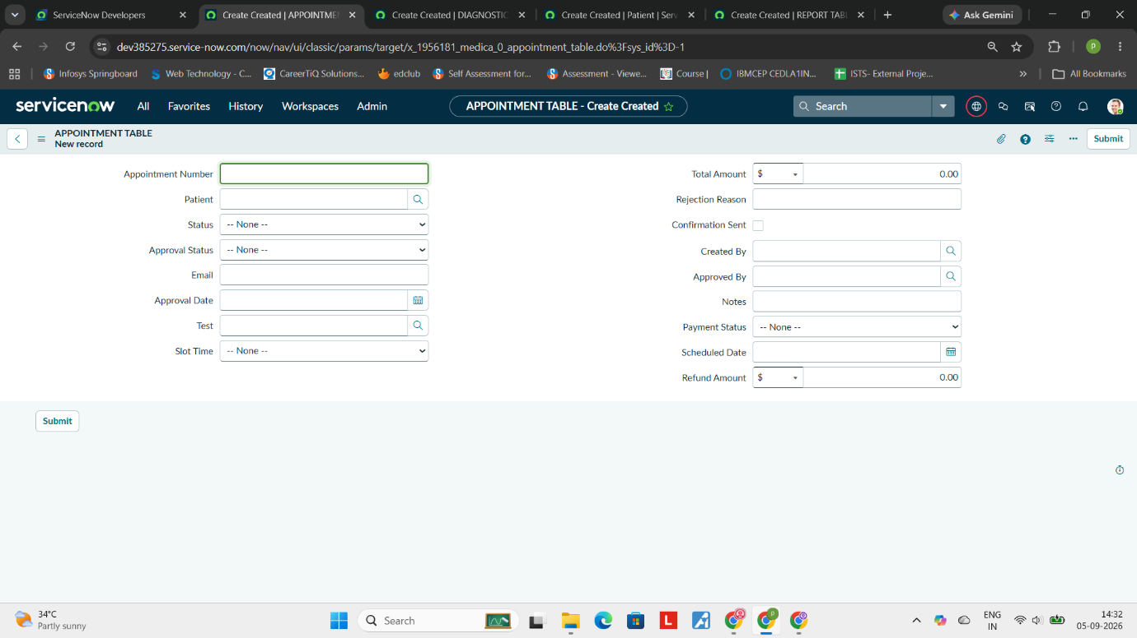

Purpose of Important Fields
- Appointment Number: Identifies each appointment.
- Patient: Connects the appointment with a patient.
- Status: Shows the current appointment stage.
- Approval Status: Tracks the approval process.
- Test: Identifies the diagnostic test selected by the patient.
- Slot Time: Stores the selected appointment time.
- Total Amount: Stores the test cost.
- Payment Status: Shows whether payment is pending, paid, failed, or refunded.
- Scheduled Date: Stores the appointment date.
- Approved By: Identifies the user who approved the appointment.
- Notes: Stores additional information about the appointment.

Activity 3: Diagnostic Test Table Creation
The Diagnostic Test Table stores information about the different tests provided by the diagnosis center.
Examples include:
- Blood Test
- X-Ray
- MRI
- CT Scan
- Ultrasound
- Cardiology Tests
Steps to Create the Table
- Go to System Definition → Tables.
- Click New.
- Enter the following details:
Field | Value
Label | Diagnostic Test
Name | x_1955296_medica_0_diagnostic_test
Application | Medical Diagnosis Center
- Verify that the correct application is selected.
- Click Submit.
The Diagnostic Test Table is created successfully.

Activity 4: Creating Fields in Diagnostic Test Table
The following fields are added to the Diagnostic Test Table.
Field Label | Field Name | Field Type | Choices / Description
Test Name | test_name | String | Name of the diagnostic test
Test Code | test_code | String | Unique code for the test
Category | category | Choice | Blood Test, Radiology, Cardiology, Pathology, Ultrasound, MRI, CT Scan, Other
Test Duration | test_duration | Integer / String | Duration in minutes
Price | price | Currency | Test price
Active | active | Boolean | True / False
Description | description | String (Multi-line) | Test details

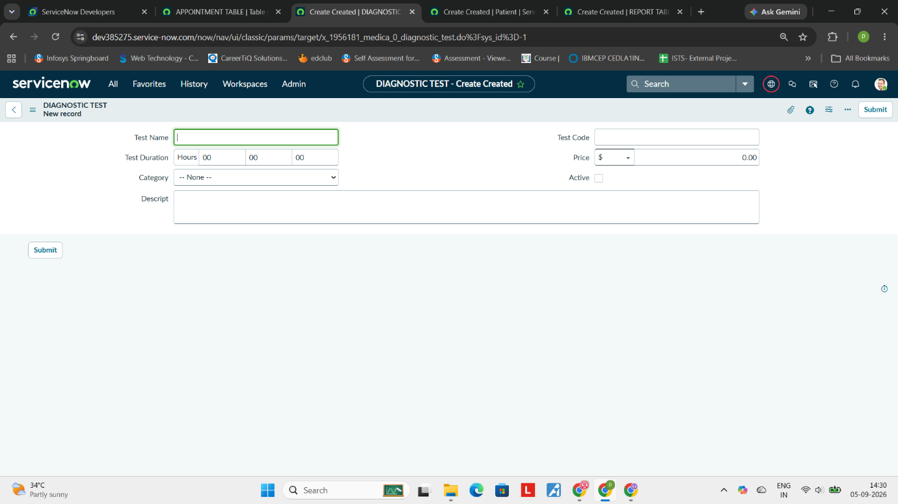
Purpose of Important Fields
- Test Name: Stores the name of the diagnostic test.
- Test Code: Provides a unique identification code for the test.
- Category: Identifies the type of diagnostic test.
- Test Duration: Stores the approximate time required to perform the test.
- Price: Stores the cost of the test.
- Active: Indicates whether the test is currently available.
- Description: Provides additional information about the test.

Relationship Between the Tables
The Appointment Table and Diagnostic Test Table are connected through the Test reference field.
For example:
Patient → Appointment → Diagnostic Test
When a patient books an appointment, the Appointment Table stores the selected diagnostic test by referencing the Diagnostic Test Table.
This relationship makes it easy to identify which test has been booked for each appointment.

Result
The required tables and fields are successfully created in the Medical Diagnosis Center application.
The Appointment Table manages patient booking and appointment-related information, while the Diagnostic Test Table manages the available diagnostic tests, categories, duration, price, and descriptions.
These tables form the basic data structure required for the appointment booking and diagnostic test management process.

Patient Table Creation and Field Configuration
The Patient Table is used to store the basic information of patients in the Medical Diagnosis Center application. It helps the system maintain patient details in one centralized place.
Activity 1: Creating the Patient Table
To create the Patient Table in ServiceNow:
- Go to System Definition → Tables.
- Click New.
- Enter the following details:
Field | Value
Label | Patient
Name | x_1955296_medica_0_patient
Application | Medical Diagnostic Center
- Check that the correct application is selected.
- Click Submit.
The Patient Table is created successfully.
Activity 2: Creating Fields
Fields are used to store different patient details in the Patient Table.
To create fields:
- Go to System Definition → Tables.
- Search for and open the Patient Table.
- Fields can be created using Form Builder, Form Design, or Form Layout.
- Create the required fields in the table.
Patient Table Fields
Field Label | Field Name | Field Type | Reference / Choices
Patient ID | patient_id | String | —
First Name | first_name | String | —
Last Name | last_name | String | —
Phone Number | phone_number | String | —
Email | email | Email | —
Gender | gender | Choice | Male, Female, Other
Date of Birth | date_of_birth | Date | —
Address | address | String (Multi-line) | —
User | user | Reference | sys_user
These fields store the patient's identification, contact, personal, and ServiceNow user information.
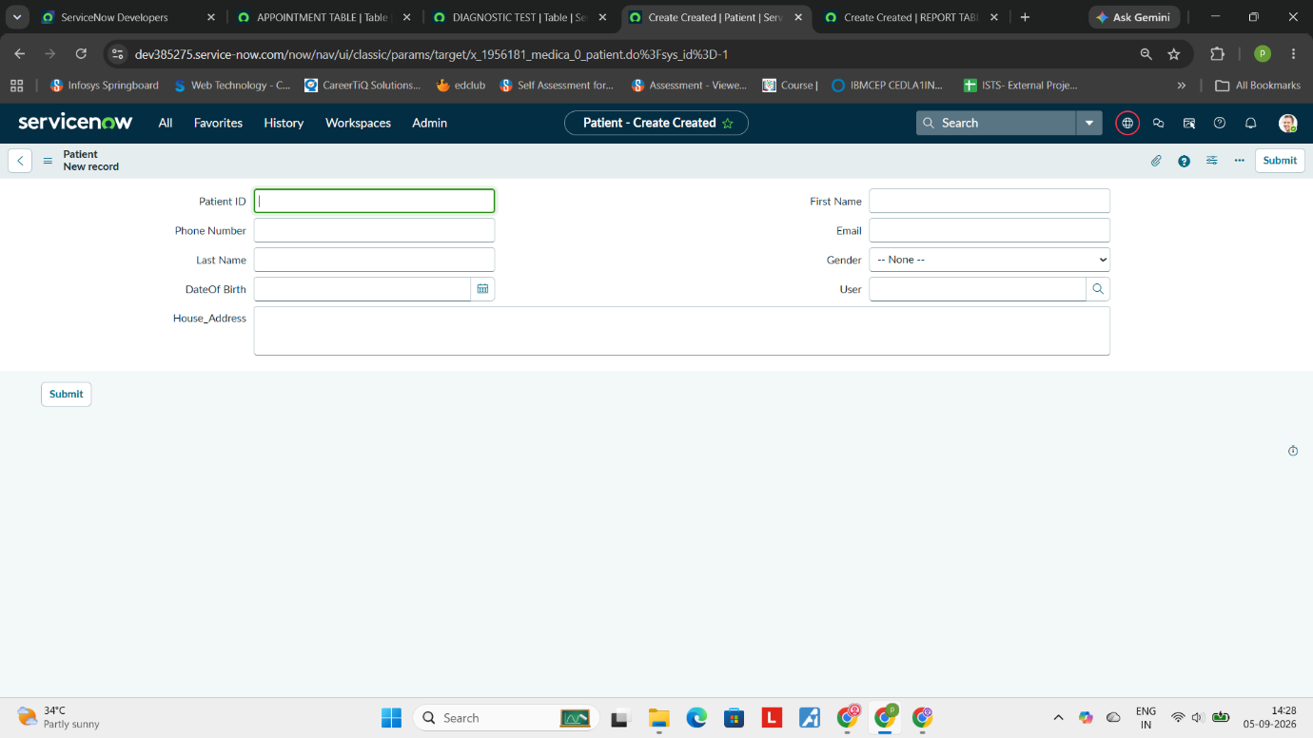

Purpose of the Fields
- Patient ID: Identifies each patient.
- First Name and Last Name: Store the patient's name.
- Phone Number: Stores the patient's contact number.
- Email: Stores the patient's email address.
- Gender: Stores the patient's gender.
- Date of Birth: Stores the patient's date of birth.
- Address: Stores the patient's address.
- User: Connects the patient record with a ServiceNow user account.
Result
The Patient Table is successfully created with the required fields. It provides a central location to store and manage patient information for the Medical Diagnosis Center application.

Table configurations(Report Table):
Activity 1: Creation of Tables
- Navigate to Tables:
  - In the Application Navigator (left-side panel), search for Tables.
  - Go to System Definition > Tables.
- Create New Table:
  - Click the New button at the top of the table list.
- Fill in Table Information:
  - Label: REPORT TABLE
  - Name: x_1955296_medica_0_report_table
  - Application: Medical Diagnostic Center (Verify that the current application scope is set correctly before saving).
- Submit:
  - Click Submit to create and save the table.
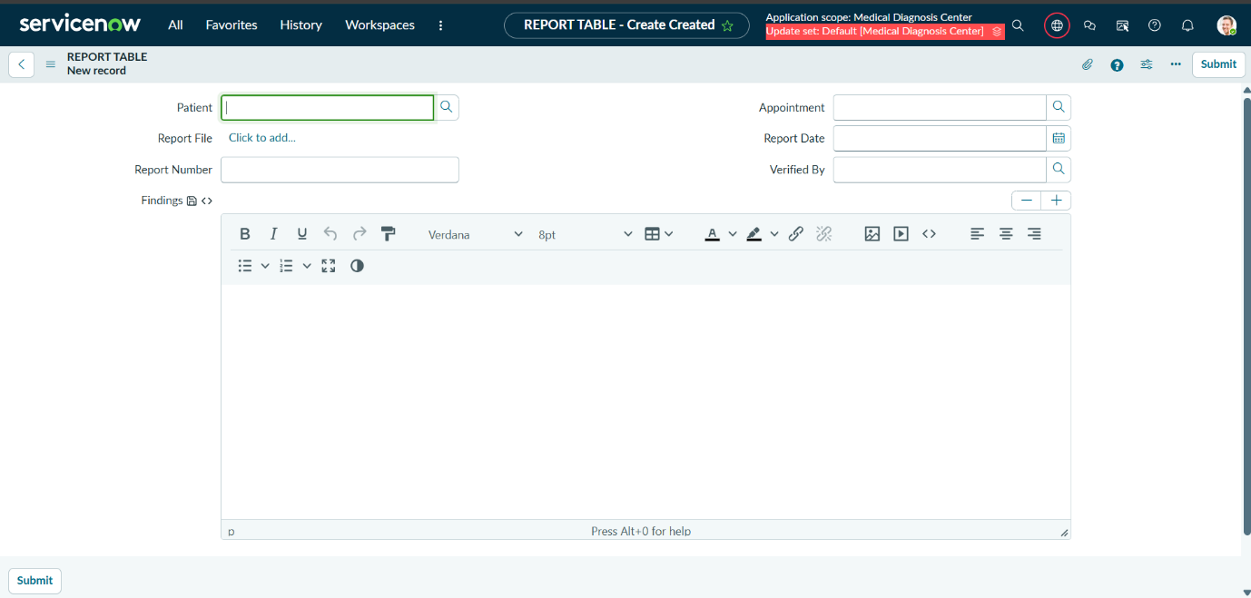

Business Rule – Cancellation Refund
A Business Rule is created to automatically calculate the refund amount when an appointment is cancelled.
When a patient cancels an appointment, the system charges 10% of the total amount as a cancellation charge and stores the remaining amount in the Refund Amount field.
Activity: Create Business Rule
Go to:
All → System Definition → Business Rules
Click New and enter:
- Name: Auto Populate Refund Amount on Cancellation
- Table: x_1955296_medica_0_appointment_table
- Advanced: True
- Application: Medical Diagnosis Center
- When to Run: Before Insert and Update
Enter the refund calculation script in the Script section and click Save.
Calculation
Cancellation Charge = Total Amount × 10%
Refund Amount = Total Amount − Cancellation Charge
For example, if the total amount is ₹1,000, the cancellation charge is ₹100 and the refund amount is ₹900.
Result
The Business Rule automatically calculates the 10% cancellation charge and updates the Refund Amount when an appointment is cancelled. This makes the refund process simple and reduces manual calculation.
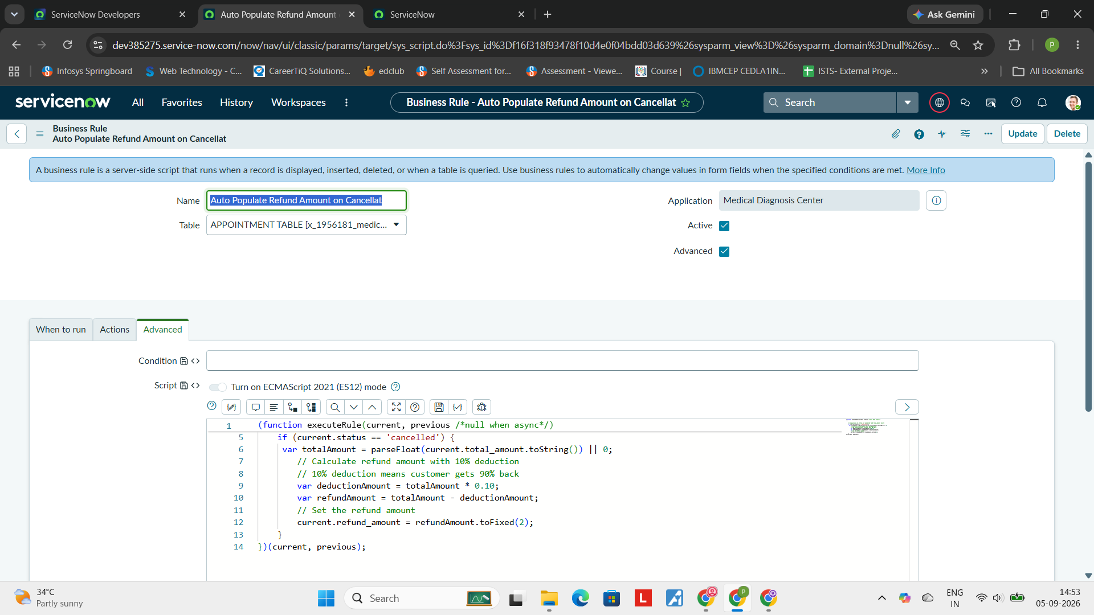

Business Rule – Automatic Report Creation
A Business Rule is created to automatically generate a diagnostic report when an appointment is completed.
When the appointment status changes to Completed, the system checks whether a report already exists. If no report is available, a new report is created automatically with the appointment, patient, test, report date, and test findings.
Activity: Create Business Rule
Go to:
All → System Definition → Business Rules
Click New and enter the following details:
- Name: Auto Create Report on Appointment Complete
- Table: x_1955296_medica_0_appointment_table
- Advanced: True
- Application: Medical Diagnosis Center
- When to Run: After Update
Enter the required script in the Script section and click Save.
Working
The Business Rule performs the following steps:
- Checks whether the appointment status is Completed.
- Checks if a report already exists for the appointment.
- Creates a unique report number.
- Gets the patient and diagnostic test details.
- Generates the test findings.
- Creates a new report record.
- Sets the report status as Ready.
- Stores the report in the Report Table.
The original script uses the appointment, patient, and report tables to perform these actions.
Result
When an appointment is marked as Completed, the system automatically creates the corresponding diagnostic report. This reduces manual work and makes report generation faster and easier.
Application Prefix: x_1955296_medica_0
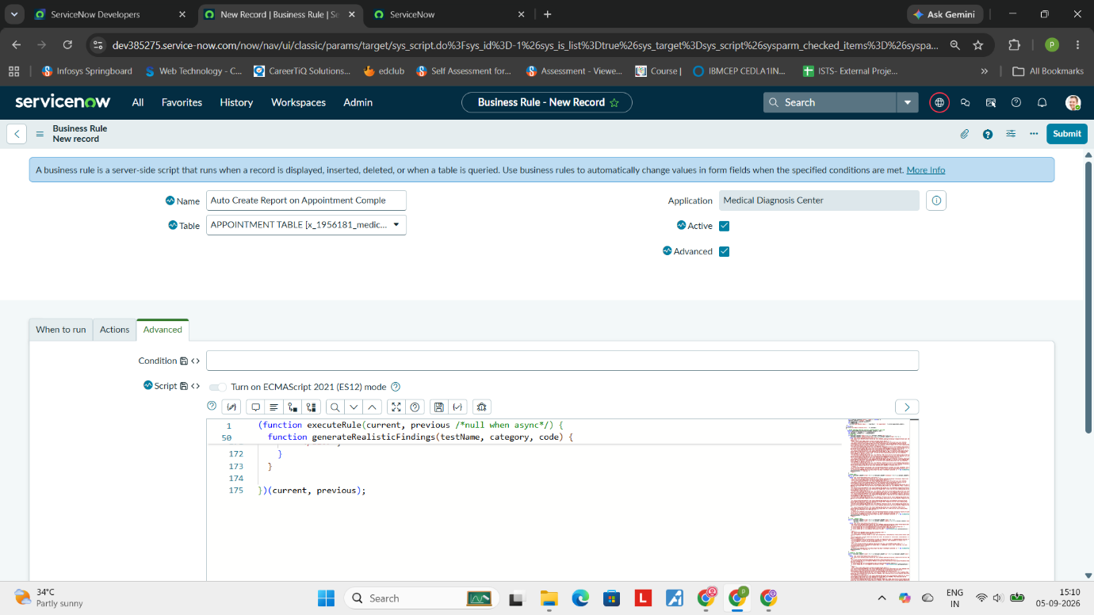

Implemented Business Rule for Rejection Details
Implemented Business Rule logic to populate the rejection details when the admin rejects an appointment slot.
Activity 1: Navigation of Business Rules
- Navigate to All Menu.
- Search for Business Rules.
- Go to System Definition → Business Rules.
- Click the New button to create a new Business Rule.
Business Rule Details
- Name: rejectionDetailsUpdation
- Table: x_1955296_medica_0_appointment
- Advanced: True
- Application: Medical Diagnosis Center
- When to Run: Before Update
Copy the required script into the Script section.
Finally, click Submit/Update to save the Business Rule.
Result
When the admin rejects an appointment slot, the Business Rule runs before the record is updated and populates the required rejection details in the appointment record.

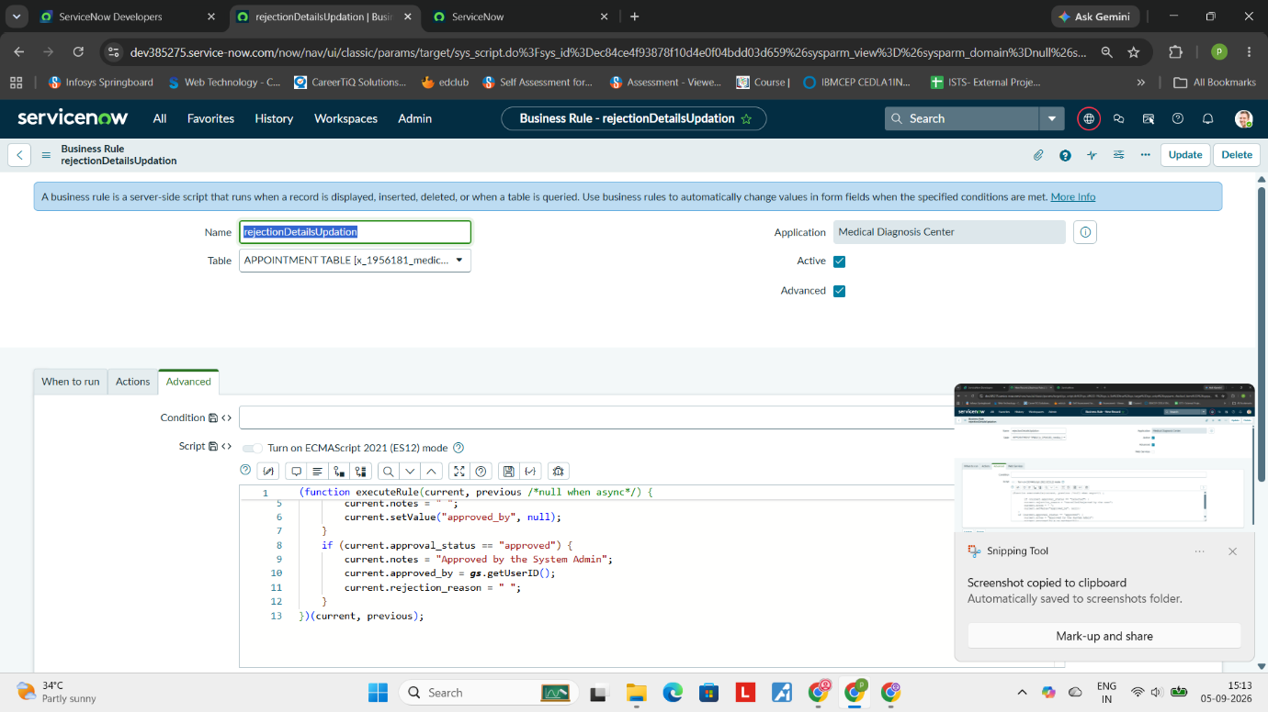

Implemented Background Script to Create Test Details Automatically
Implemented Background Script logic to create the required Test Details automatically using a script. This helps to create multiple test records quickly without entering each record manually.
Activity 1: Navigation of Background Scripts
- Navigate to All Menu.
- Search for Background Scripts.
- Go to System Definition → Background Scripts.
- Open the Background Scripts page.
- Paste the required script into the script editor.
- Click on Run Script.
- The script executes and creates the test records automatically.
Table Used
The test details are stored in the application Test table using the application prefix:
x_1955296_medica_0
Working
- The Background Script contains the required test information.
- When the script is executed, it creates new test records automatically.
- The records are stored in the Test table.
- The created test details can then be displayed and used in the Service Portal.
Result
Test records are successfully created automatically using the Background Script and are displayed in the Service Portal for users to view and use while booking tests.
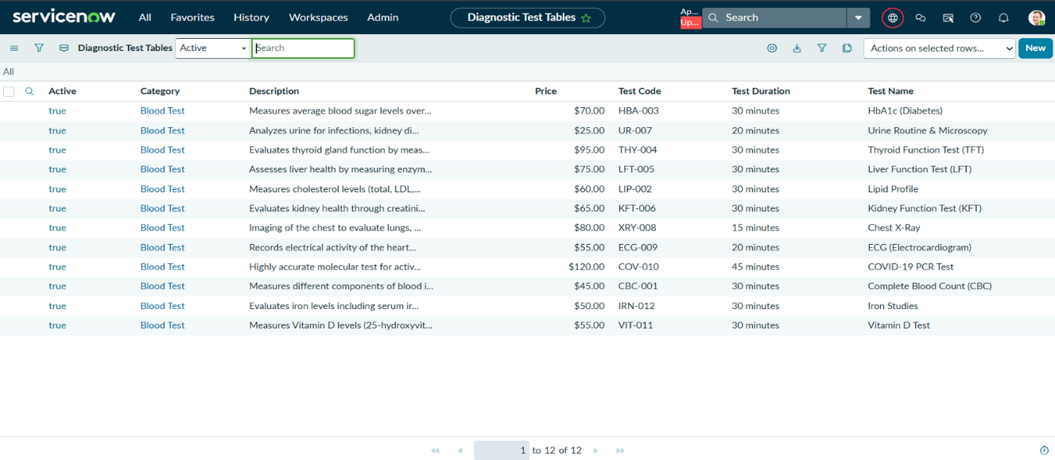

PHASE – 3
UI/UX Development & Customization
Interface design
Creation of the Service Portal
The Medical Diagnostic Center Service Portal provides an online interface for users to access the services of the diagnostic center.
The user opens the Medical Diagnostic Center portal using the configured URL suffix mdc.
- The portal displays the configured homepage.
- Users can access the available application features through the portal.
- The portal connects with the ServiceNow application and displays the required information from the application tables.
- Users can use the portal to access services such as test booking, appointments, and reports.
- The portal provides a simple interface so that users do not need to directly access the ServiceNow backend.
- Additional pages and features can be added to the portal as part of the next configuration steps.

Usage of the Service Portal
The Service Portal is used as the main user interface for the Medical Diagnostic Center application.
For Patients
- View available diagnostic tests.
- Book a test appointment.
- Check appointment details.
- Track appointment status.
- View available medical reports.
- Access other services provided through the portal.
For Diagnostic Center Staff
- Manage patient and appointment information.
- View and process test bookings.
- Update appointment details and status.
- Manage reports and related information.
- Monitor application activities.
Result
The Service Portal provides a single online platform for accessing the Medical Diagnostic Center services. It makes the application easier to use and provides a clear interface for patients and staff.
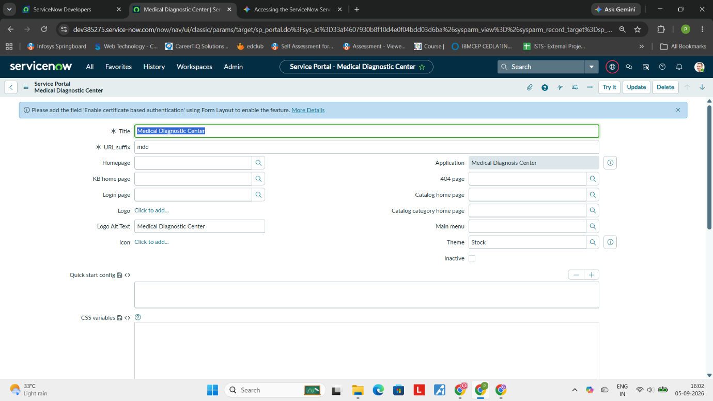

Home Logo Configuration

The Home Logo Configuration subtask provides instructions and a custom CSS script to design an animated, styled brand logo on the ServiceNow Service Portal page.
Implementation Location
- Where to apply: In the ServiceNow Service Portal record for your project, paste the provided code directly into the CSS Variables field.
Key CSS Features & Styling Included
- Custom Animations:
  - shimmer: Creates a moving light effect across the brand text.
  - pulse: Adds an animated glowing box-shadow around the navbar brand box.
  - heartbeat: Subtly scales the brand badge to give it a beating effect.
  - ecgMove: Animates a line under the brand logo to resemble an active ECG pulse wave.
- Branding Badge (::before element):
  - Displays a red gradient badge containing the text "MDC" (Medical Diagnosis Center) positioned directly before the logo text.
- Brand Text & Container:
  - Wraps the navbar brand in a semi-transparent dark container with rounded corners (12px border-radius) and a subtle backdrop blur.
  - Styles the text in uppercase bold font with a shimmering text-gradient transition from white to cyan (#00b4d8 / #7dd3fc).
- Hover Effects:
  - Accelerates the shimmer and pulse animations while slightly lifting the button (transform: translateY(-1px)).

- Responsive Design:
  - Adjusts font sizes, padding, and spacing automatically for screens smaller than 768px.

Creation of Widgets (Medical Test Catalog)
The currently selected subtask provides step-by-step instructions and full source code to build the Medical Test Catalog widget for the ServiceNow Service Portal. This widget allows users to search, filter, sort, and book available diagnostic tests.
Step-by-Step Creation Steps
- Open the Application Navigator in ServiceNow and click All.
- Search for Service Portal and select Widgets.
- Click New and fill in the details:
  - Name: Medical Test Catalog
  - ID: x_1955296_medica_0
  - Public: Check this box (makes it accessible to all users)
  - Description: Widget to display and manage functionalities
- Click Submit or Save.
- Click Open in Widget Editor in the Related Links section to paste the code scripts.
Code Components Included
- HTML Code (Template):
  - Hero Banner: Displays a search bar with dynamic search filtering, total test counts, and quick branding badges.
  - Quick Action Cards: Direct navigation shortcuts to My Bookings and My Reports.

  - Category Tabs & Sorting: Allows users to filter tests by category (e.g., Blood, Imaging, Cardiology) and sort by Name, Price, or Duration.
  - Test Cards Grid: Displays test details, codes, categories, pricing, and dynamic Book Now buttons.
- CSS Code (Styling):
  - Modern card grid layout using custom CSS variables (dark blue and cyan theme).
  - Smooth animations for glowing pulse dots, floating hero icons, and hover transformations.
  - Fully responsive styling optimized for screen widths under 768px.
- Client Script (AngularJS):
  - Handles live search filtering (filterTests) and category switching (setCategory).
  - Automatically maps test categories to relevant emojis (e.g., Blood → 🩸, Cardiology → ❤️).
  - Stores selected test parameters in sessionStorage and redirects users to the appointment_booking page when Book Now is clicked.
- Server Script (ServiceNow Scripting):
  - Queries the custom table my_appointments using Glide Record.
  - Fetches active diagnostic test records including test name, code, category, description, duration, and price.
  - Dynamically populates the category list for the frontend tabs.

Creation of Widgets (My Appointments)
The currently selected task provides instructions and code to build the My Appointments widget (my_appointments) for the ServiceNow Service Portal, allowing patients to view and manage their booked diagnostic tests.
Step-by-Step Creation Steps
- Open the Application Navigator in ServiceNow and click All.
- Search for Service Portal and select Widgets.
- Click New and fill in the following details:
  - Name: My Appointments
  - ID: my_appointments
  - Public: Checked (makes it accessible to all portal users)
  - Description: Widget to display and manage functionalities
- Click Submit or Save.
- Select Open in Widget Editor from the Related Links section to paste the code scripts.
Code Components Included
- HTML Template:
  - Header & Quick Action: Displays a title banner with a Book New Test button.
  - Summary Stats Bar: Shows counts for Total, Confirmed, Pending, and Completed appointments.
  - Filter Tabs & Search Bar: Enables filtering by status (All, Pending, Confirmed, Completed, Cancelled) and live keyword searching or sorting (Newest, Oldest, Status).
  - Appointment List & Cards: Renders test name, appointment number, scheduled date/time slot, price, payment status, approval status, and notes/rejection reasons.
  - Action Buttons: Options for View Details, Cancel, and View Report (when available).
  - Detail Modal: A popup overlay displaying full metadata for a selected appointment.
- CSS Styling:
  - Styled using custom CSS variables (dark blue --primary: #0a2463 and cyan --accent: #00b4d8).
  - Features color-coded status pills (e.g., green for paid/approved, yellow for pending, red for cancelled/rejected).
  - Includes smooth hover cards, responsive mobile layout tweaks, and modal popup animations (slideUp).
- Client Script (AngularJS):
  - Initializes statistics and handles dynamic list filtering and tab switching.
  - Provides modal visibility controls (showModal, openModal, closeModal).
  - Maps appointment categories to emoji icons and formats statuses and colors dynamically.

Creation of Widgets (Appointment Booking)
The currently selected task provides instructions and code to build the Appointment Booking widget (appointment_booking) for the ServiceNow Service Portal, guiding patients through a multi-step booking process.
Step-by-Step Creation Steps
- Open the Application Navigator in ServiceNow and select All.
- Search for Service Portal and choose Widgets.
- Click New and fill in the details:
  - Name: Appointment Booking
  - ID: appointment_booking
  - Public: Checked (makes it accessible to all portal users)
  - Description: Widget to display and manage functionalities
- Click Submit or Save.
- Click Open in Widget Editor in the Related Links section to paste the code scripts.
4-Step Workflow Included
- Step 1: Patient Information
  - Selected test banner displaying category icon, test code, duration, price, and a "Change Test" option.
  - Input fields for First Name, Last Name, Email, Phone Number, Date of Birth, Gender (dropdown), and Address.
- Step 2: Schedule Appointment
  - Preferred date picker with minimum-date restriction (disables past dates).
  - Time slot selection grid with dynamic error messaging.
  - Booking Summary breakdown showing test name, patient details, date, time, and total amount.
- Step 3: Payment
  - Order summary listing test fee, $0.00 service fee, and total amount.
  - Support for 5 payment methods:
    - Card: Cardholder Name, Number, Expiry, CVV.
    - UPI: UPI ID and quick app selection (GPay, PhonePe, Paytm, BHIM, Amazon Pay).
    - Net Banking: Bank dropdown selection.
    - Insurance: Provider name and Policy/Member ID.
    - Pay on Arrival (Cash): Cash payment instruction notice.
- Step 4: Confirmation (Done)
  - Generated Appointment Number and booking recap.
  - Payment status and pending approval alert.
  - Next steps breakdown (Email confirmation, Admin approval within 24 hours, 24h reminder alert).
  - Direct buttons to View My Bookings or Book Another Test.
Styling & Features
- CSS: Uses the primary dark blue (#0a2463) and cyan (#00b4d8) theme with step-indicator line progress animation.
- AngularJS Logic: Step validation prevents advancing without required fields, formats dates, handles dynamic time-slot selection, and calculates payment summaries.
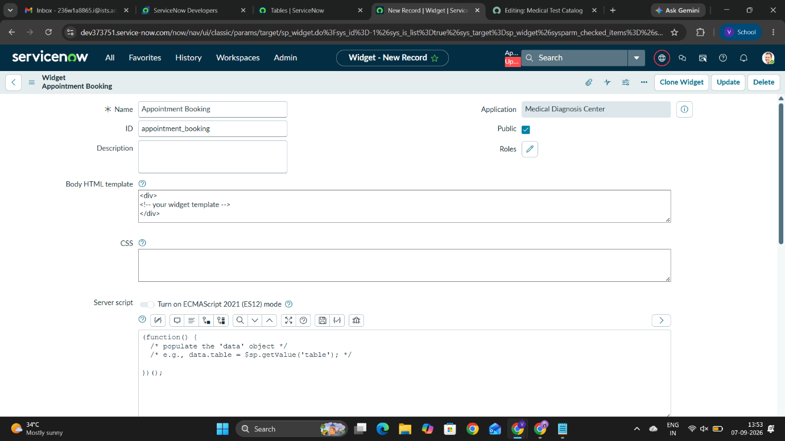

Creation of Widgets (Lab Reports)
The currently selected task provides instructions and source code to build the Lab Reports widget (lab_reports) for the ServiceNow Service Portal, enabling patients to view, search, and download their diagnostic test results.
Step-by-Step Creation Steps
- Open the Application Navigator in ServiceNow and select All.
- Search for Service Portal and choose Widgets.
- Click New and fill in the details:
  - Name: Lab Reports
  - ID: lab_reports
  - Public: Checked (makes it accessible to all portal users)
  - Description: Widget to display and manage functionalities
- Click Submit or Save.
- Click Open in Widget Editor under Related Links to paste the template scripts.
Key Features & Code Components
- HTML Template:
  - Header & Quick Navigation: Title header with direct buttons to return Home or go to My Bookings.
  - Live Summary Stats Bar: Metrics counter displaying Total Reports, Ready, Pending, and Completed tests.
  - Search & Sort Controls: Real-time search bar (by test name, report number, or doctor) and sorting options (Newest First, Oldest First, Test Name).
  - Report Cards & Metadata: Displays test date, report date, assigned doctor, category, and remarks.
  - Rich HTML Findings Table: Renders medical test parameters and findings directly inside the card and detail modal.
  - Interactive Actions: Direct View Details modal overlay and a Download Report button when a report file is available.
- CSS Styling:
  - Styled with theme variables using primary dark blue (#0a2463) and cyan (#00b4d8).
  - Features color-coded status pills (e.g., green for Ready/Completed, yellow for Pending, blue for Processing).
  - Styled dynamic tables inside report findings with responsive slide-up modal animations.
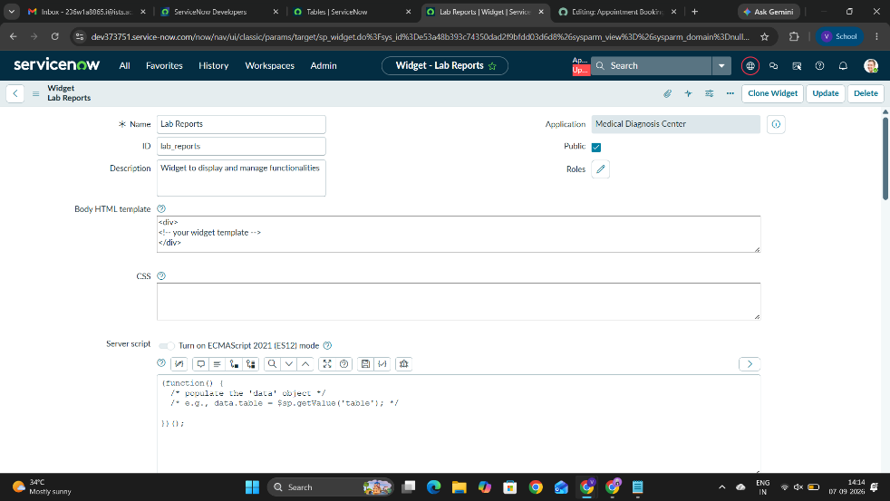
Creation of Pages (Test Catalog Home Page):
The Creation of Pages (Test Catalog Home Page) task involves setting up a new, publicly accessible page within ServiceNow's Service Portal framework.
To complete this, you navigate to the Service Portal > Pages module in the Application Navigator, create a new record, and define the page with:
- Title: Test Catalog
- ID: test_catalog
- Page Type: Standard
- Description: A dedicated page for the Medical Diagnostic Center within the Service Portal
- Accessibility: Set as Public so users/patients can access it without logging in.
Saving the record generates the base page structure, which can then be customized with widgets for the diagnostic center.
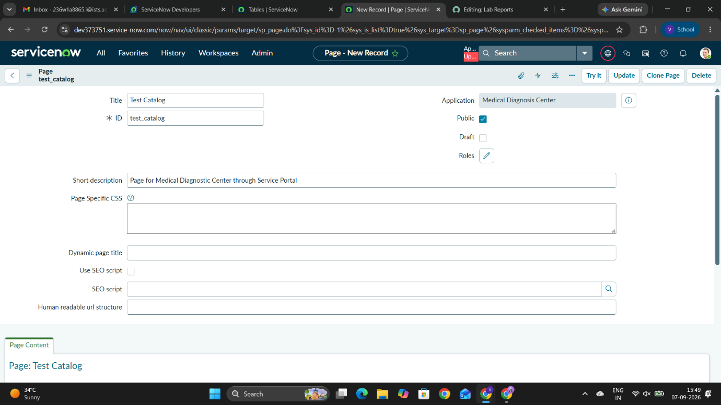

Creation of Pages (Book Appointment):
This task involves creating a new, publicly accessible portal page in ServiceNow designated for booking appointments at the Medical Diagnostic Center.
Configuration Details:
- Page Title: Book Appointment
- ID: appointment_booking
- Page Type: Standard
- Description: Page for Medical Diagnostic Center through Service Portal
- Make Public: True (Checked)
Brief Overview: Navigate to Service Portal > Pages in the Application Navigator, create a new record, fill in the page details above, and save to establish the appointment booking page.
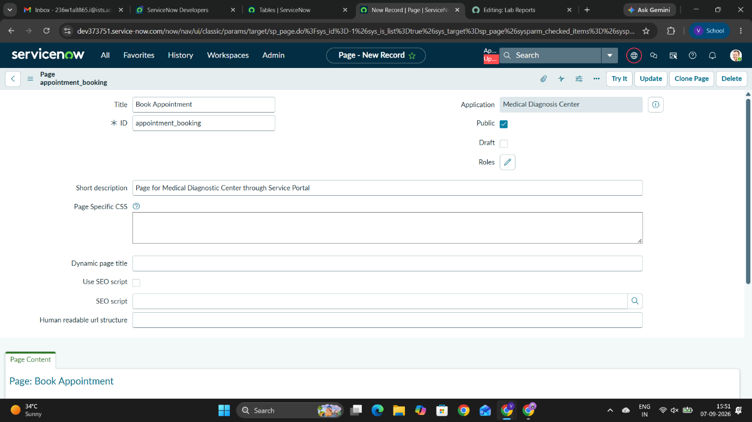

Creation of Pages (My Appointments):
Configuration Details:
- Page Title: My Appointments
- ID: my_appointments
- Page Type: Standard
- Description: Page for Medical Diagnostic Center through Service Portal
- Make Public: True (Checked)
Brief Overview: This task involves creating a new, publicly accessible portal page in ServiceNow where users and patients can view and manage their scheduled appointments. To set it up, navigate to Service Portal > Pages in the Application Navigator, click New, fill in the configuration details above, and save the record.
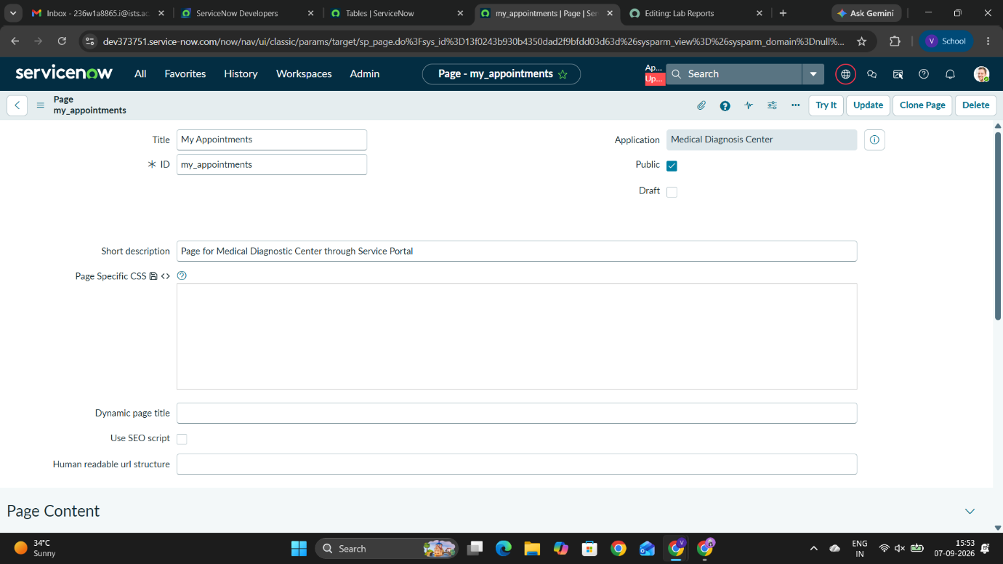
Creation of Pages (Lab Reports):
This task involves creating a new, publicly accessible portal page in ServiceNow for patients and users to view their medical lab test results.
Configuration Details:
- Page Title: Lab Reports
- ID: lab_reports
- Page Type: Standard
- Description: Page for Medical Diagnostic Center through Service Portal
- Make Public: True (Checked)
Brief Overview: Navigate to Service Portal > Pages in the Application Navigator, click New, fill in the configuration details above, and save the record to establish the page structure for displaying lab reports.
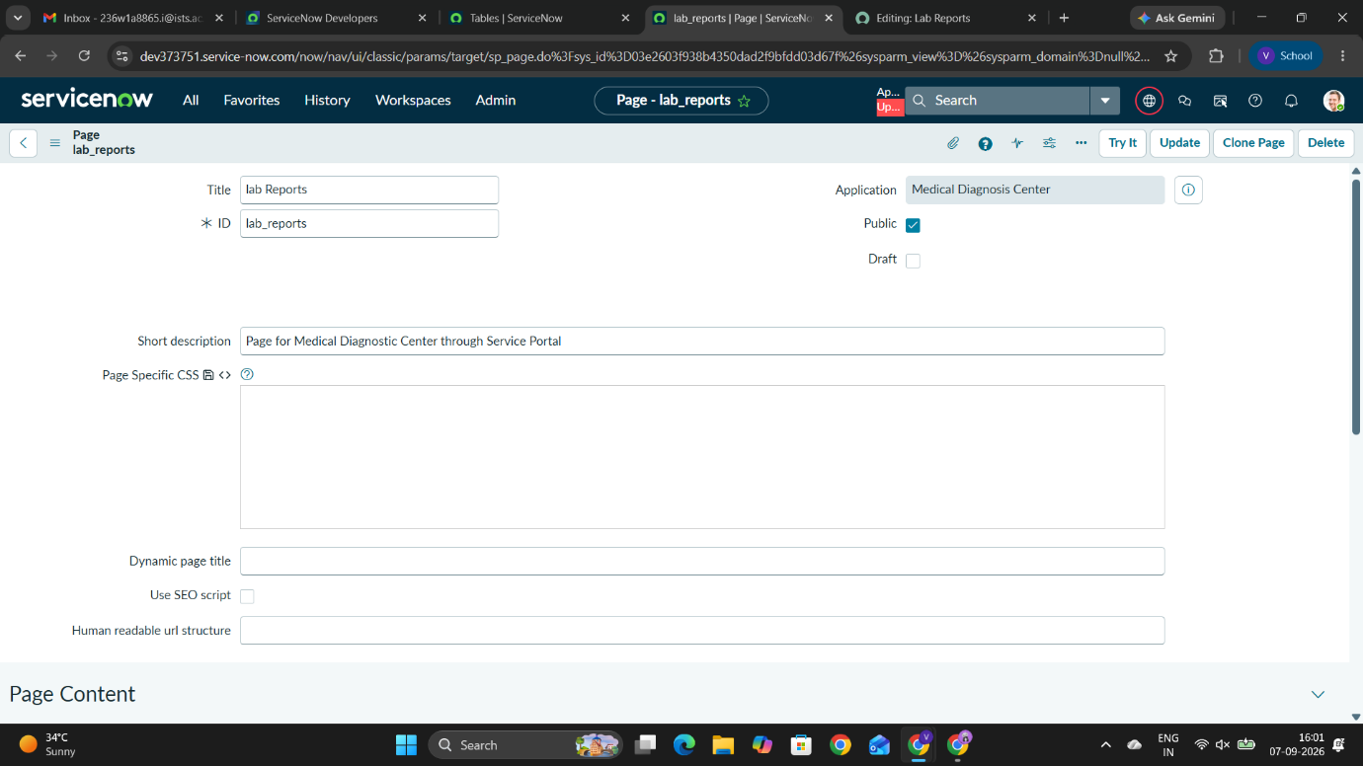

Page Configuration:

The Page Configuration subtask provides instructions for assembling the Service Portal pages using ServiceNow's Service Portal Designer by placing the newly created custom widgets onto their corresponding pages.
Step-by-Step Instructions
- Open the created portal page in ServiceNow (such as test_catalog or any of your newly created pages).
- Click on the Open in Designer option located in the Related Links section of the page record.
- Add Containers and Rows to the layout as required (select the Container 12 format for a full-width layout).
- Search for your custom widgets in the left pane and drag them onto the page (e.g., add the medical_test_catalog widget to the test_catalog page).
- Drag and arrange the widgets to align with your target UI/UX design.
- Click Save (or let Service Portal Designer auto-save) to preserve the page layout.
Note: Follow this exact same layout configuration process to attach each created widget (my_appointments, appointment_booking, lab_reports) to its respective page.
Client Script (AngularJS):
  - Uses $sce.trustAsHtml to safely render structured HTML report data and findings tables.
  - Handles live client-side searching, sorting, modal popups, and stat recalculations.
Workflow of the Medical Diagnosis Center Portal
The end-to-end user and system workflow across the Service Portal interfaces follows this sequence:

1. Browsing Diagnostic Tests (Test Catalog)
- User Action: The patient logs into the Service Portal or accesses the public home page (test_catalog).
- System Process: The Medical Test Catalog widget queries active diagnostic tests from the backend table (x_1955296_medica_0_diagnostic_test).
- Interaction: The user filters tests by category (Blood, Imaging, Cardiology, etc.), searches by keyword, or sorts by price/duration, then clicks Book Now on a selected test.
2. Appointment Booking Process (4-Step Form)
- Step 1 (Patient Details): Patient verifies/enters personal information (Name, Email, Phone, DOB, Gender, Address).
- Step 2 (Schedule): Patient chooses an available appointment date and selects a time slot.
- Step 3 (Payment): Patient selects a payment method (Card, UPI, Net Banking, Insurance, or Pay on Arrival) and completes transaction details.
- Step 4 (Confirmation): The system processes the request, creates a record, generates an Appointment Number, and sets the initial status to Requested / Pending Approval.
3. Request Handling & Approval (Backend Workflow)
- Automated Notification: The system sends an email/portal alert confirming the booking request.
- Approval/Verification:
  - Simple/standard tests move automatically to Confirmed.
  - Specialized tests trigger a manager/lab staff approval task.
- Status Updates: Upon approval, the appointment updates to Confirmed with a scheduled time for sample collection.

4. Tracking & Managing Appointments (My Appointments)
- User Action: Patient visits the my_appointments page.
- Interaction: The user tracks their booking through dynamic states (Pending Approval → Confirmed → Sample Collected → Processing → Completed).
- Options: Patients can view appointment metadata, cancel pending bookings, or check payment and approval notes.

5. Lab Processing & Report Generation (Lab Reports)
- Lab Action: Lab staff complete the diagnostic test and upload/attach the completed findings and medical values.
- Status Change: The appointment moves to Completed, and the report status updates to Ready.
- Patient Retrieval: The patient navigates to the lab_reports page to view interactive summary metrics, inspect test findings via a pop-up modal, or download the full report document.

Page Configuration Overview
The Page Configuration subtask provides instructions for assembling the Service Portal pages using ServiceNow's Service Portal Designer by placing the newly created custom widgets onto their corresponding pages.

Step-by-Step Instructions
- Open the created portal page in ServiceNow (such as test_catalog or any of your newly created pages).
- Click on the Open in Designer option located in the Related Links section of the page record.
- Add Containers and Rows to the layout as required (select the Container 12 format for a full-width layout).
- Search for your custom widgets in the left pane and drag them onto the page (e.g., add the medical_test_catalog widget to the test_catalog page).

- Drag and arrange the widgets to align with your target UI/UX design.
- Click Save (or let Service Portal Designer auto-save) to preserve the page layout.
Note: Follow this exact same layout configuration process to attach each created widget (my_appointments, appointment_booking, lab_reports) to its respective page.

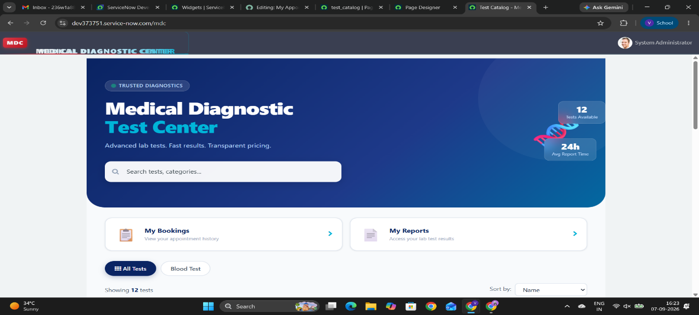

PHASE – 4
DATA MIGRATION AND SECURITY
Data Handling
Data Handling phase, you are setting up automatic email alerts in ServiceNow to keep customers informed during two specific events:
- Appointment Approvals: Sends an automated email to the customer whenever an appointment's status is changed to "Approved" (x_1955296_medica_0_appointment table).
You set up an automated email rule named Approval Notifications targeting the appointment table(x_1955296_medica_0_appointment).
Here is how it works:
- Trigger: It evaluates every time an appointment record is either created or updated.
- Condition: It fires only when the Approval Status field actively changes to Approved.
- Outcome: ServiceNow automatically sends a notification email to inform the customer that their appointment request has been officially approved.
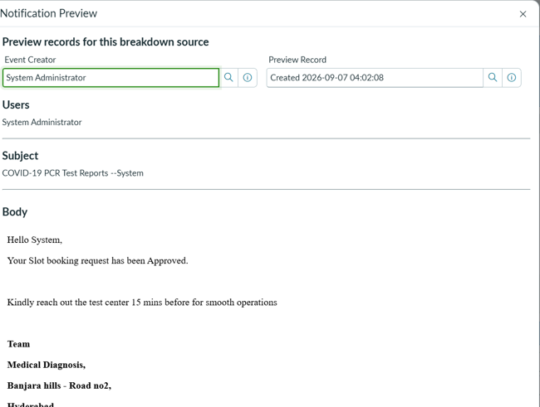
- Report Generation: Triggers an automated email to the customer as soon as a new medical report record is created with a valid report number (x_1955296_medica_0_report_table table).
In Activity 2, you set up an automated email rule named reportsNotifications targeting the medical report table (x_1955296_medica_0_report_table).
Here is how it works:
- Trigger: It evaluates whenever a new record is created (Record Inserted) in the report table.
- Condition: It fires only when the Report number field is Not Empty (confirming a valid report ID exists).
- Outcome: ServiceNow automatically sends an email notification to inform the customer that their medical diagnosis report has been generated and is ready.
This phase establishes automated communication pipelines in ServiceNow to notify customers instantly when their appointments are approved and when their medical test reports are ready.
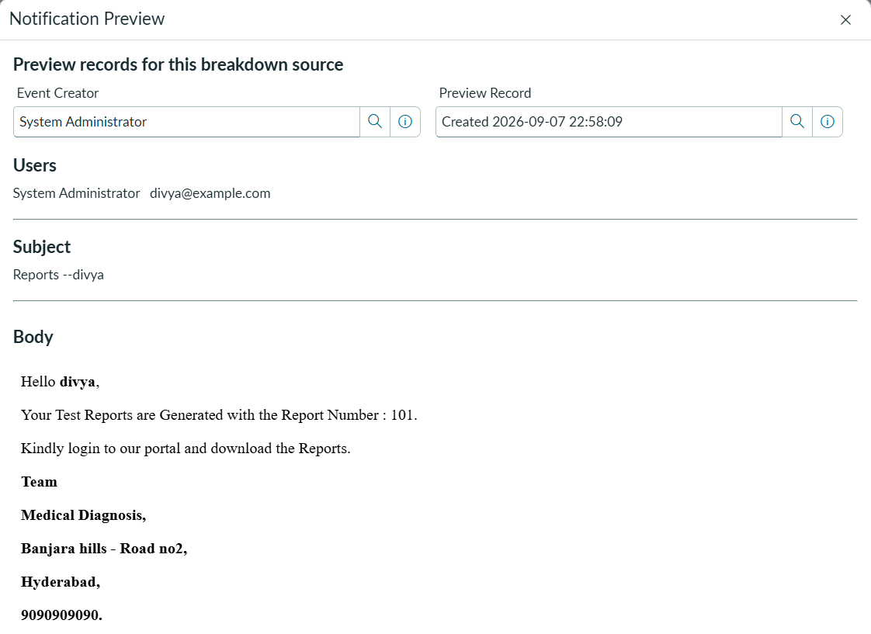

Access Control :
Purpose & Objective
The primary goal of this phase is to establish secure Role-Based Access Control Rules (ACLs) in ServiceNow. It ensures that while end users/clients can interact with front-end services (like making bookings or requests), backend database tables and sensitive fields remain strictly protected against unauthorized access or tampering.

Key Concepts & Implementation Details
- Separation of Front-End Services and Database Access
  - Concept: End users interact with the system strictly through front-end forms and portal interfaces.
  - Security Rule: Direct access to raw database tables (tables where record data is stored) is blocked for general users. They can trigger records via the portal without having backend table browsing permissions.
- Utilization of Default Table ACLs
  - Concept: When creating custom tables in ServiceNow, the platform automatically generates 4 default ACL rules (Create, Read, Write, and Delete).
  - Implementation: Instead of creating redundant rules from scratch, the configuration relies on and tunes these 4 out-of-the-box ACLs to maintain optimal security with minimal custom maintenance.
- Role-Based Field & Operation Security
  - Concept: Access rights are mapped strictly to user roles.
  - Implementation: Specific fields (especially sensitive customer or medical data) are restricted so that only users possessing assigned roles can read or modify them. Unassigned users are completely blocked from viewing or editing those fields.

PHASE -5
DEPLOYMENT , DOCUMENTATION & FINAL PRESENTATION
Reporting and Dashboards
Here is a detailed explanation of the Reporting & Dashboards story currently open on your screen:
Purpose & Objective
This phase focuses on visual data aggregation and monitoring within ServiceNow. By building custom reports and organizing them on a centralized dashboard, administrators and managers gain real-time visibility into appointment volumes, tracking approval statuses and progress at a glance.
Implementation Breakdown
- Activity 1: Centralized Dashboard Setup
  - Location: Usage and Governance > Dashboard
  - Goal: Create a unified workspace container named Health Reports Dashboard.
  - Purpose: Acts as a single-pane-of-glass interface where multiple analytics widgets and operational reports are embedded for easy monitoring.

- Activity 2: Appointment Metrics Reporting
  - Location: Usage and Governance > Reports
  - Goal: Build a custom report named Appointments Reports sourced from the underlying appointment table (x_1955296_medica_0_appointment).
  - Visual Type: Bar Chart
  - Configuration:
    - Group By: Status (Categorizes appointments by their current stage).
    - Additional Group By: Approval Status (Sub-divides data by approval state).
    - Stack By: Created, Approval Date (Provides time-based visual stacking).
    - Aggregation: Count (Displays total record totals per grouping).
- Dashboard Integration
  - Action: Once configured and verified, the report is published directly onto the Health Reports Dashboard using the sharing menu to finalize the visual reporting view.
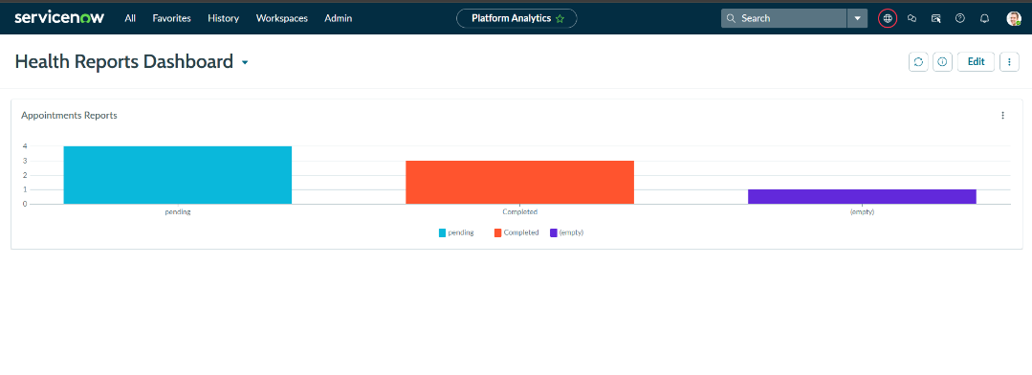
QA & UAT Testing
This QA & UAT Testing story focuses on end-to-end user acceptance testing of the Medical Diagnosis Center portal, verifying everything from appointment booking to automated email triggers.
Core Testing Workflow
- Service Portal End-to-End User Flow:
  - Login & Booking: Log into the Medical Diagnosis Center portal (/mdc), select Book Now, fill in user details, select a time slot, and proceed to payment.
  - Confirmation & History: Complete payment to trigger the booking confirmation pop-up (showing Appointment Number, Date, and Time), then check the My Reports and Bookings section to verify history and status updates.
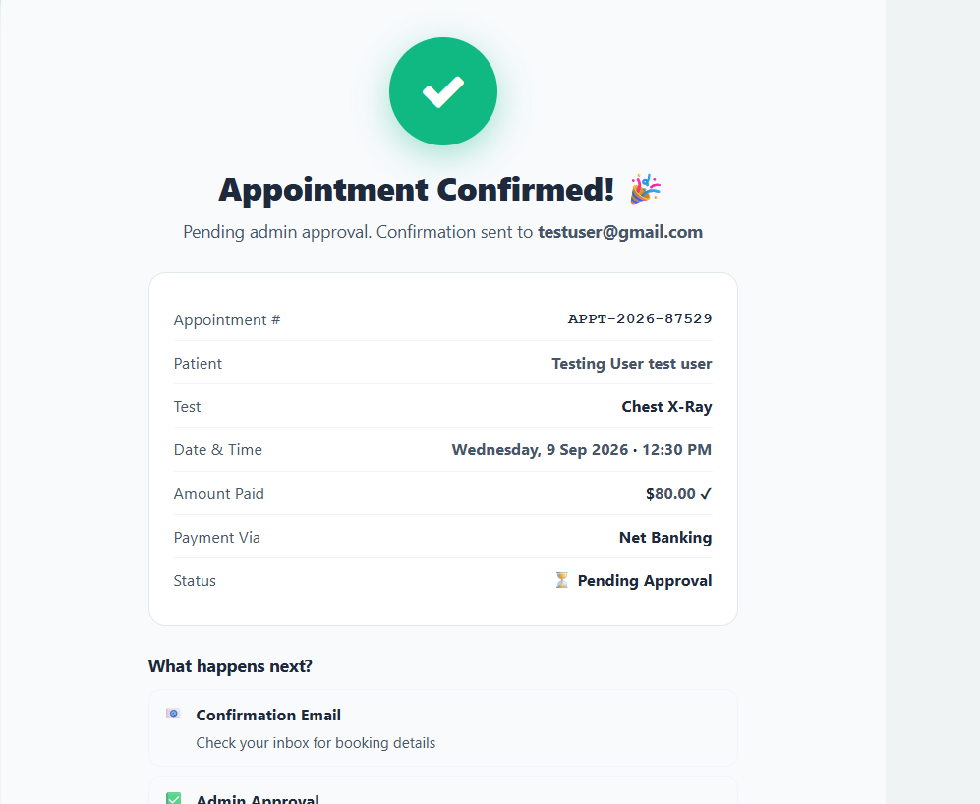
- Backend & Email Notification Verification:
  - Record Generation: Verify that completing a booking automatically creates a new entry in the Appointment table.
  - Approval & Logs Verification: Navigate to System Logs > Emails to confirm initial system emails, update the appointment record's Approval status to Approved, and verify that the approval notification email is generated correctly using Preview Email.

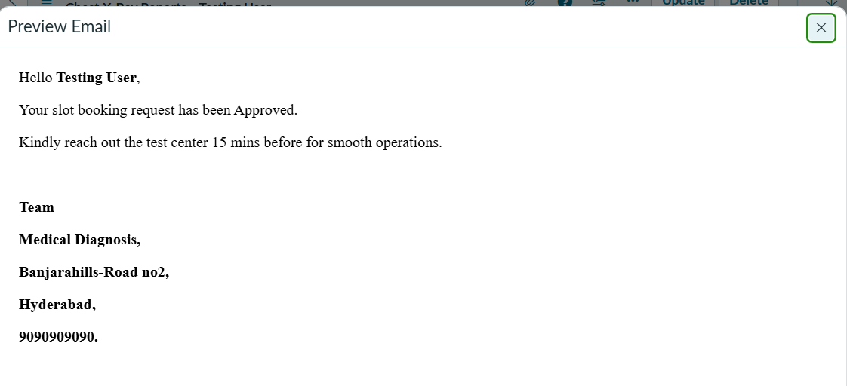

Reports Generation
This Reports Generation story covers the automated creation of medical reports and customer notification workflow upon completing an appointment.
Workflow Summary
- Automated Generation (Business Rule):
  - When an admin updates an appointment's status to Completed and its approval status to Approved, a Business Rule automatically triggers to generate the medical report record in the Reports table.
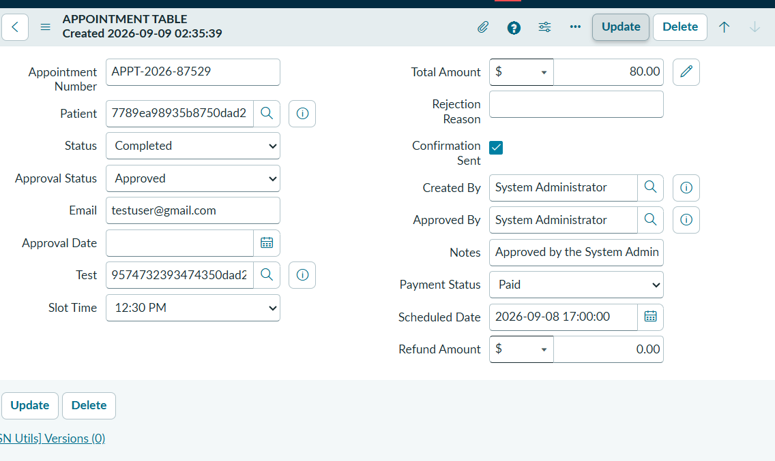
- Verification & Email Trigger:
  - Verify report creation directly within the Reports table in the backend.
  - Creating this report record automatically triggers an email notification to the customer (verifiable under System Logs > Emails).
- Portal Download:
  - Once notified via email, the user logs into the portal and downloads their generated medical report directly from the My Reports section.

Troubleshooting
This Troubleshooting story covers debugging and resolving core technical issues across the Medical Diagnosis Center ServiceNow application.
Key Focus Areas
- Appointment Booking & Slot Validation: Debugged booking conflicts, overlapping slots, incorrect date validations, auto-populating test prices from the Diagnostic Test table, and payment status updates using System Logs, gs.info() statements, browser console logs, and GlideRecord debugging.
- Data Binding & Variable Population: Resolved broken data mapping between Service Portal widgets, Record Producers, Flow Designer, and custom tables (Patient, Appointment, Diagnostic Test, Report) by verifying server/client script objects, $scope variables, and reference field mappings.
- Email & Notification Triggers: Resolved missing or misdirected emails (booking confirmation, approval/rejection, payment, report ready, and cancellation alerts) by inspecting event queues (gs.eventQueue), Email Logs, and previewing email templates.
- Security & Access Control (ACLs): Fixed permission issues—such as patients seeing other records or staff lacking upload/creation rights—using Security Debugging tools, role-based login testing, and user impersonation to enforce strict table- and field-level ACLs.

Adherence to Timelines
This Adherence to Timelines story (estimated duration: 5 minutes) focuses on ensuring project delivery within defined milestones using a structured and iterative development approach.

Key Highlights
- Milestone Delivery: Delivered the Diagnostic Test Center Portal on schedule by sticking to a structured development plan across portal design, booking workflows, payment integration, and report management.

- Core Feature Prioritization: Prioritized high-impact healthcare requirements—such as slot scheduling, test availability validation, payment confirmation, and report generation—to prevent delivery delays.
- Iterative Testing & Issue Resolution: Used continuous testing cycles to catch booking conflicts, data discrepancies, and workflow bottlenecks early, minimizing rework.
- Cross-Component Alignment: Coordinated configurations across Service Portal widgets, Flow Designer, custom tables, ACL security rules, and notifications (email/SMS) to stay aligned with scheduled go-live timelines.
- Deployment Validation & Reliability: Pre-validated automated approvals, test reminders, payment tracking, and report publishing before deployment to satisfy stakeholder expectations on schedule while ensuring system security and accuracy.

CONCLUSION:
Key Highlights
- Comprehensive Healthcare Solution: Successfully delivers an end-to-end healthcare workflow covering slot availability, appointment booking, automated approvals, report delivery, and patient notifications using Service Portal, custom widgets, Flow Designer, and scheduled jobs.
- Security & Alignment: Maintains high data security standards (via ACLs) and operational realism, ensuring reliable report management and consistent patient communication.
- Architecture & Best Practices: Built on a scalable, modular ServiceNow architecture designed for easy maintenance, sustainability, and smooth future updates.
- Future Scope: Prepares the platform for future enhancements like payment gateway integration, advanced analytics dashboards, mobile app support, and integration with hospital management systems (HMS).

*** THANK YOU***

